PRACTICAL NO. 01

- Configure Routers:

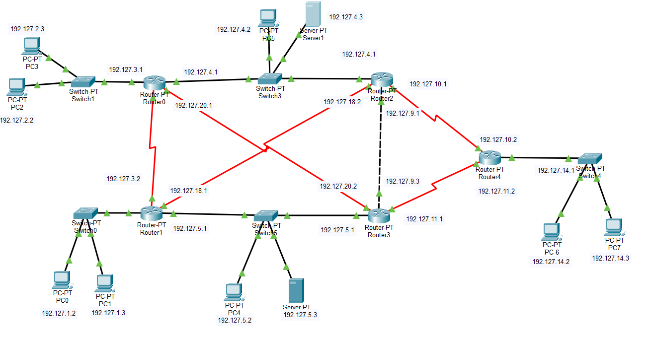

Addressing Table:-

Device | Interface | IP Address | Subnet Mask | Default Gateway | Notes
Router0 | Fa0/0 | 192.127.2.1 | 255.255.255.0 | N/A | To Switch1
Router0 | Fa1/0 | 192.127.4.1 | 255.255.255.0 | N/A | To Switch3
Router0 | Se2/0 | 192.127.20.1 | 255.255.255.0 | N/A | To Router2
Router0 | Se3/0 | 192.127.3.1 | 255.255.255.0 | N/A | To Router1
Router1 | Fa0/0 | 192.127.5.1 | 255.255.255.0 | N/A | To Switch2
Router1 | Fa1/0 | 192.127.1.1 | 255.255.255.0 | N/A | To Router0
Router1 | Se3/0 | 192.127.18.1 | 255.255.255.0 | N/A | To Router0
Router1 | Se2/0 | 192.127.3.2 | 255.255.255.0 | N/A | To Router0
Router2 | Fa0/0 | 192.127.5.1 | 255.255.255.0 | N/A | LAN
Router2 | Fa1/0 | 192.127.9.2 | 255.255.255.0 | N/A | To Router3
Router2 | Se2/0 | 192.127.10.1 | 255.255.255.0 | N/A | To Router4
Router2 | Se3/0 | 192.127.18.2 | 255.255.255.0 | N/A | To Router0
Router3 | Fa0/0 | 192.127.5.1 | 255.255.255.0 | N/A | To Router4
Router3 | Fa1/0 | 192.127.9.3 | 255.255.255.0 | N/A | To Router2
Router3 | Se2/0 | 192.127.20.2 | 255.255.255.0 | N/A | To Router4
Router3 | Se3/0 | 192.127.11.3 | 255.255.255.0 | N/A | To Router4
Router4 | Fa0/0 | 192.127.14.1 | 255.255.255.0 | N/A | To Switch5
Router4 | Se2/0 | 192.127.11.2 | 255.255.255.0 | N/A | To Router3
Router4 | Se3/0 | 192.127.10.3 | 255.255.255.0 | N/A | To Router2
PC0 | Fa0 | 192.127.1.2 | 255.255.255.0 | 192.127.1.1 | LAN
PC1 | Fa0 | 192.127.1.3 | 255.255.255.0 | 192.127.1.1 | LAN
PC2 | Fa0 | 192.127.2.2 | 255.255.255.0 | 192.127.2.1 | LAN
PC3 | Fa0 | 192.127.2.3 | 255.255.255.0 | 192.127.2.1 | LAN
PC4 | Fa0 | 192.127.5.2 | 255.255.255.0 | 192.127.5.1 | LAN (Router1)
Server0 | Fa0 | 192.127.5.3 | 255.255.255.0 | 192.127.5.1 | Connected to Router1
PC5 | Fa0 | 192.127.4.2 | 255.255.255.0 | 192.127.4.1 | LAN
Server1 | Fa0 | 192.127.4.3 | 255.255.255.0 | 192.127.4.1 | Connected to Router0
PC6 | Fa0 | 192.127.14.2 | 255.255.255.0 | 192.127.14.1 | LAN
PC7 | Fa0 | 192.127.14.3 | 255.255.255.0 | 192.127.14.1 | LAN

Assigning IP to the router (CLI):-

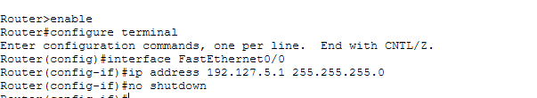

For OSPF

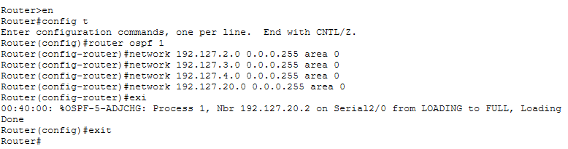

Now checking the established connection:-

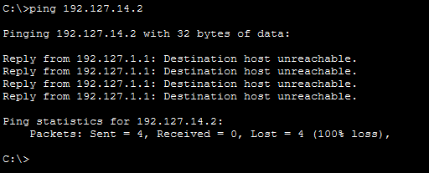

Checking IP route:-

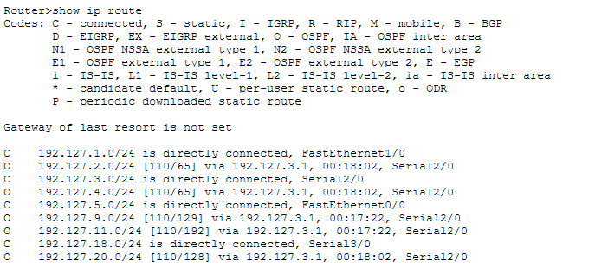

- OSPF MD5 authentication.

For OSPF MD5 authentication

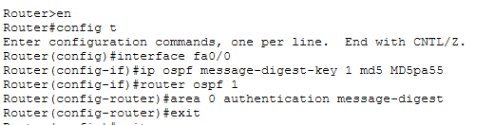

After Show ip ospf

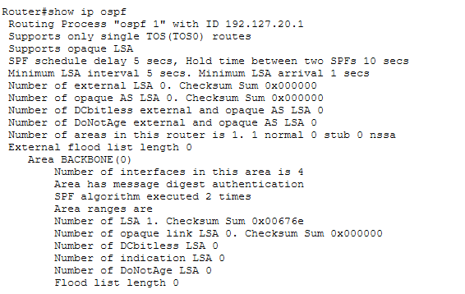

After authentication is enabled

Router#show ip ospf interface

FastEthernet0/0 is up, line protocol is up
Internet address is 192.127.4.1/24, Area 0
Process ID 1, Router ID 192.127.20.1, Network Type BROADCAST, Cost: 1
Transmit Delay is 1 sec, State DR, Priority 1
Designated Router (ID) 192.127.20.1, Interface address 192.127.4.1
No backup designated router on this network
Timer intervals configured, Hello 10, Dead 40, Wait 40, Retransmit 5
Hello due in 00:00:08
Index 1/1, flood queue length 0
Next 0x0(0)/0x0(0)
Last flood scan length is 1, maximum is 1
Last flood scan time is 0 msec, maximum is 0 msec
Neighbor Count is 0, Adjacent neighbor count is 0
Suppress hello for 0 neighbor(s)
Message digest authentication enabled
Youngest key id is 1
Serial2/0 is up, line protocol is up
Internet address is 192.127.20.1/24, Area 0
Process ID 1, Router ID 192.127.20.1, Network Type POINT-TO-POINT, Cost: 64
Transmit Delay is 1 sec, State POINT-TO-POINT,
Timer intervals configured, Hello 10, Dead 40, Wait 40, Retransmit 5
Hello due in 00:00:08
Index 2/2, flood queue length 0
Next 0x0(0)/0x0(0)
Last flood scan length is 1, maximum is 1
Last flood scan time is 0 msec, maximum is 0 msec
Neighbor Count is 1 , Adjacent neighbor count is 1
Adjacent with neighbor 192.127.20.2
Suppress hello for 0 neighbor(s)
Message digest authentication enabled
Youngest key id is 1
Serial3/0 is up, line protocol is up
Internet address is 192.127.3.1/24, Area 0
Process ID 1, Router ID 192.127.20.1, Network Type POINT-TO-POINT, Cost: 64
Transmit Delay is 1 sec, State POINT-TO-POINT,
Timer intervals configured, Hello 10, Dead 40, Wait 40, Retransmit 5
Hello due in 00:00:07
Index 3/3, flood queue length 0
Next 0x0(0)/0x0(0)
Last flood scan length is 1, maximum is 1
Last flood scan time is 0 msec, maximum is 0 msec
Neighbor Count is 1 , Adjacent neighbor count is 1
Adjacent with neighbor 192.127.18.1
Suppress hello for 0 neighbor(s)
Message digest authentication enabled
Youngest key id is 1
FastEthernet1/0 is up, line protocol is up
Internet address is 192.127.2.1/24, Area 0
Process ID 1, Router ID 192.127.20.1, Network Type BROADCAST, Cost: 1
Transmit Delay is 1 sec, State DR, Priority 1
Designated Router (ID) 192.127.20.1, Interface address 192.127.2.1
No backup designated router on this network
Timer intervals configured, Hello 10, Dead 40, Wait 40, Retransmit 5
Hello due in 00:00:07
Index 4/4, flood queue length 0
Next 0x0(0)/0x0(0)
Last flood scan length is 1, maximum is 1
Last flood scan time is 0 msec, maximum is 0 msec
Neighbor Count is 0, Adjacent neighbor count is 0
Suppress hello for 0 neighbor(s)
Message digest authentication enabled
Youngest key id is 1

- NTP.

Here we defined a ntp server which will provide times to other routers and add it to any network and also assign default gateway as well .

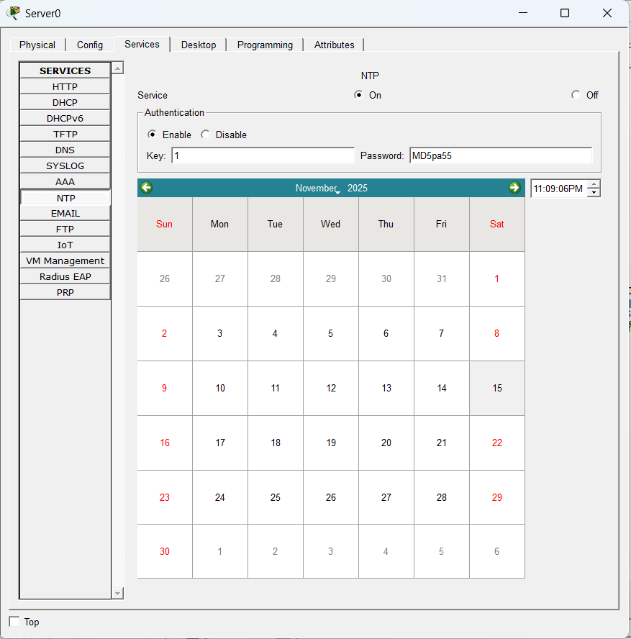

Now set ntp server as a date provider for routers.

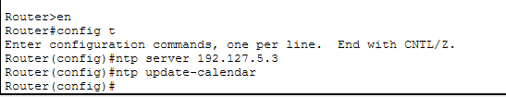

Then checking time on routers.

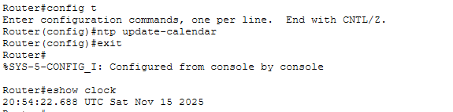

- to log messages to the syslog server.

First enable syslog server as below:

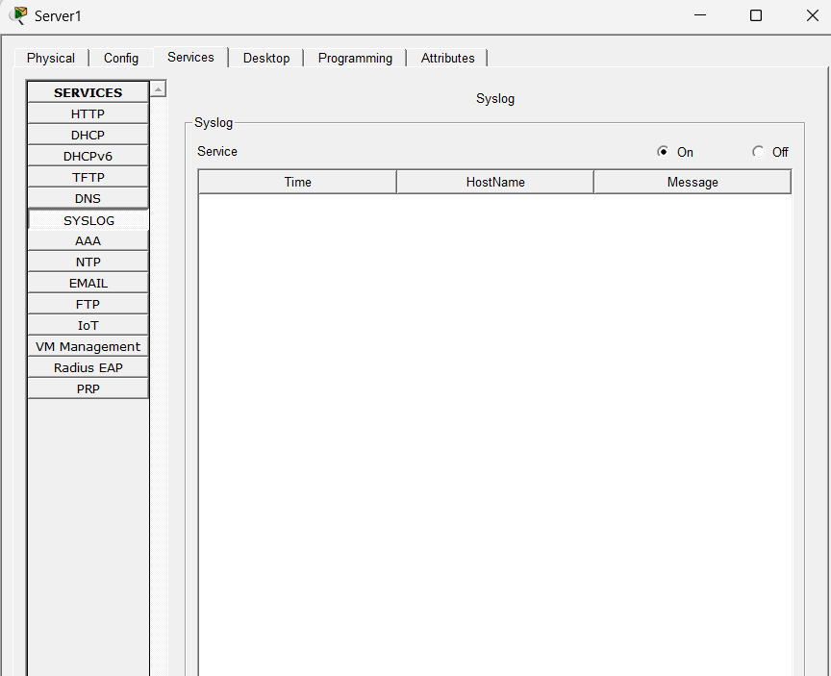

Now we will assign syslog server ip to the router to maintain logs.
As below:-

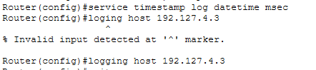

Now we will use commands to check whether the logs are stored or not.

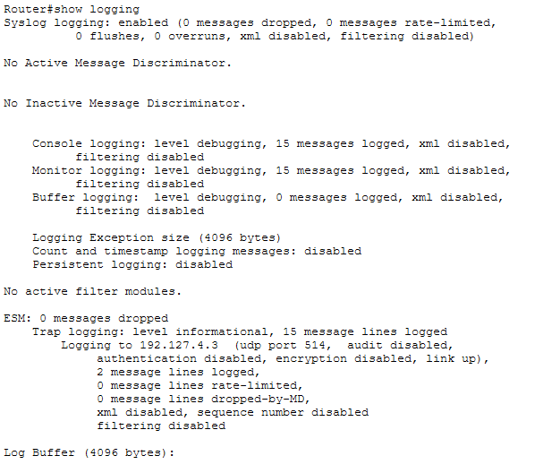

We can also check on syslog server logs to check logs.

